System for Award Management Documentation

INSTRUCTIONS: The submission of the System for Award Management (SAM) documentation is required for all CDBG applicants and associated entities as identified in the CDBG Application Guidelines Part II, Section 1.03. Documentation to be provided includes 1) SAM Registration and 2) Exclusion Status.

To access SAM: www.sam.gov

For those applications that involve additional entities:
- For-Profit Business: Both the business and the business owner need to be reviewed within SAM. The business owner does not need to be registered within SAM; however, documentation must be provided that indicates that the business owner is not excluded from receiving federal funds.

In addition, applications that involve a for-profit business must provide documentation for the Non-Profit Development Organization (NDO) associated with the application. The NDO must be registered within SAM and demonstrate that they are not excluded from receiving federal funds.

- Non-Profit Entity: The non-profit organization must be registered within SAM and demonstrate that they are not excluded from receiving federal funds.

The following are instructions to access the documentation based on the user type:
- Not the Entity Owner: an individual who did not set up the account within the SAM system.
- Entity Owner: the representative tasked with setting up the account within the SAM system.

Instructions: Not the Entity Owner

Go to sam.gov and click on “Sign In” on the right side of the screen
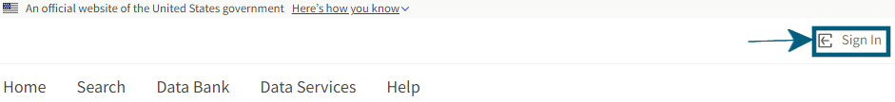

Accept the terms to sign into the site
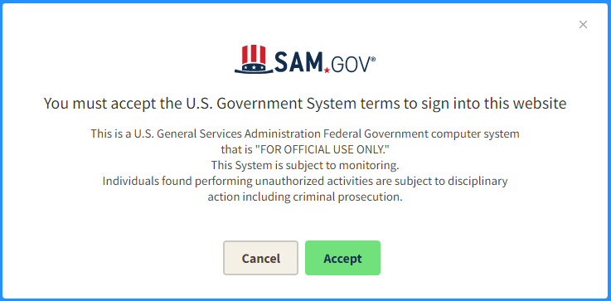

Enter your login.gov sign-in credentials, if you do not have sign-in credentials, please create an account
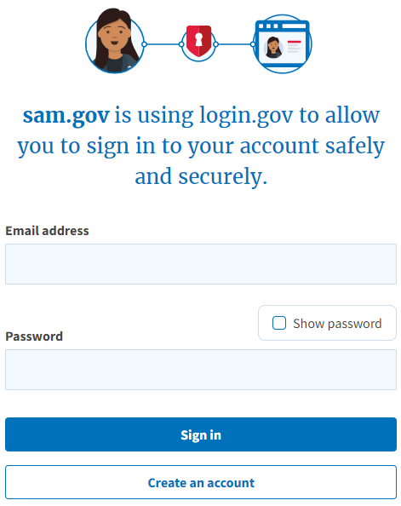

Once you sign into the account, click on “Search” at the left side of the screen.
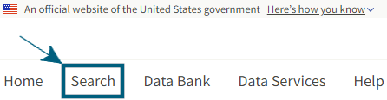

Either type the name of the organization in the top Search Box or the Keywords box.
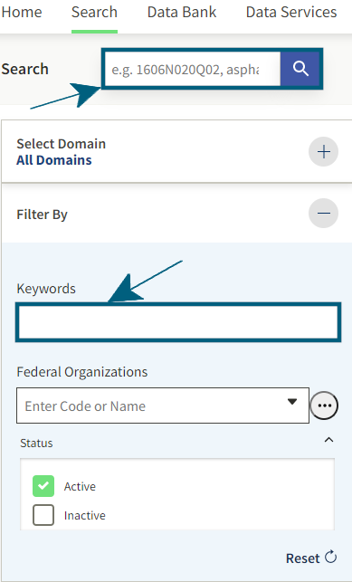

Click on the plus sign (+) next to Select Domain
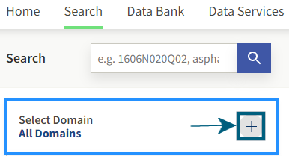

Click on “Entity Information in the drop down
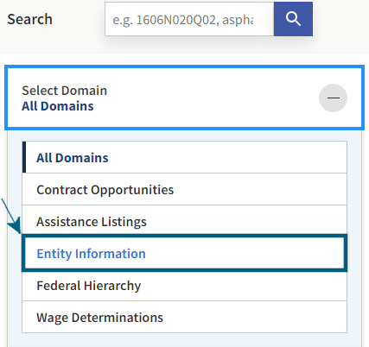

If the location area is not expanded, click on the drop down arrow next to location. Under State / Province, enter Nebraska in the “Input Text” box.
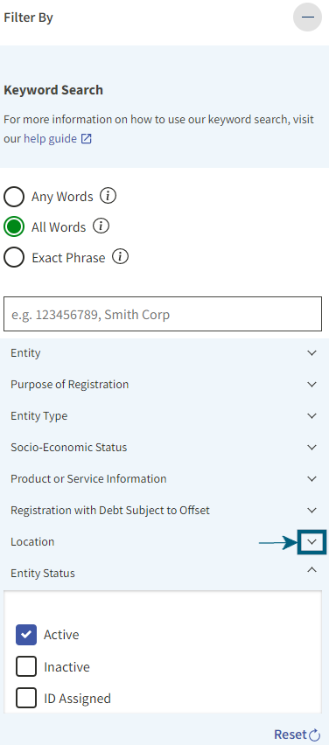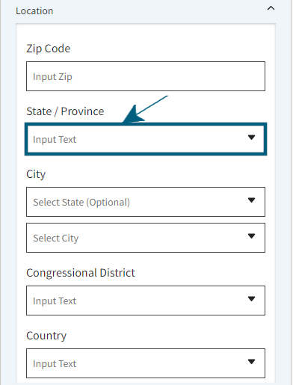

Select the result by clicking on the name.
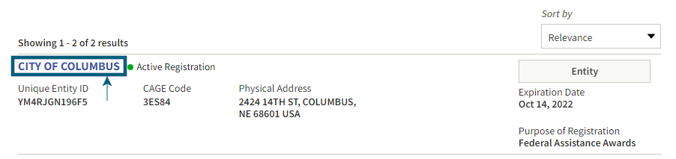

The following screen will populate.
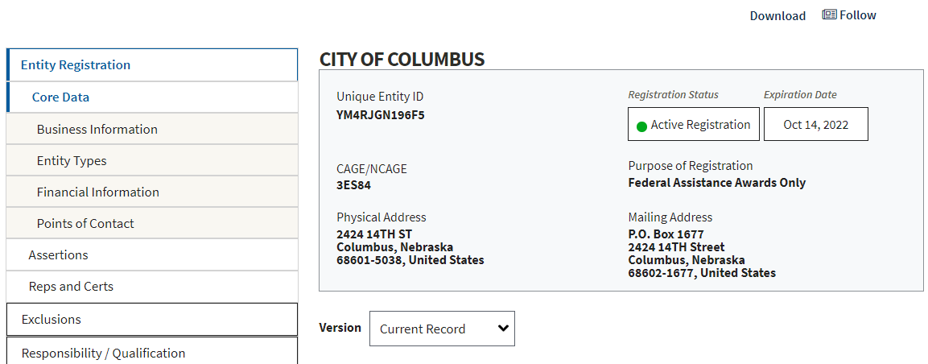

Click on “Download.”
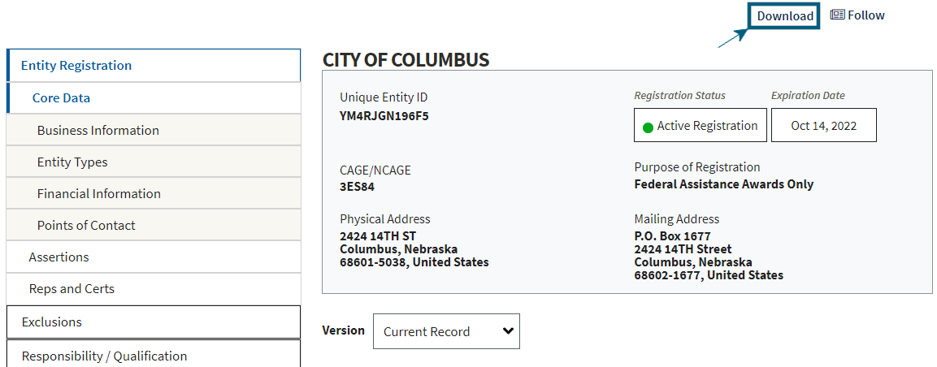

Select the file type, enter the file name, then click on the download button. For example, if your entity was DED, type DED-20220609 (20220609 is the year, month, day), then click on the PDF file type, then click on the download button. Depending on your browser, it should ask you to save the PDF file. This download documents the registration of the entity.

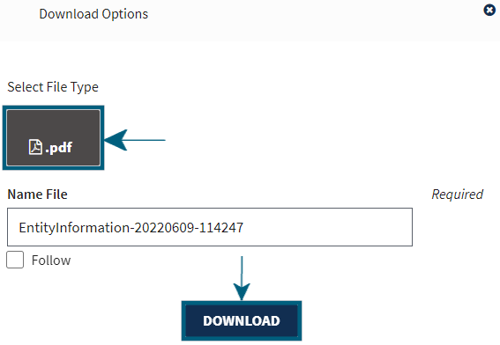

To document the status of exclusions, select “Exclusions” on the left side of the screen.
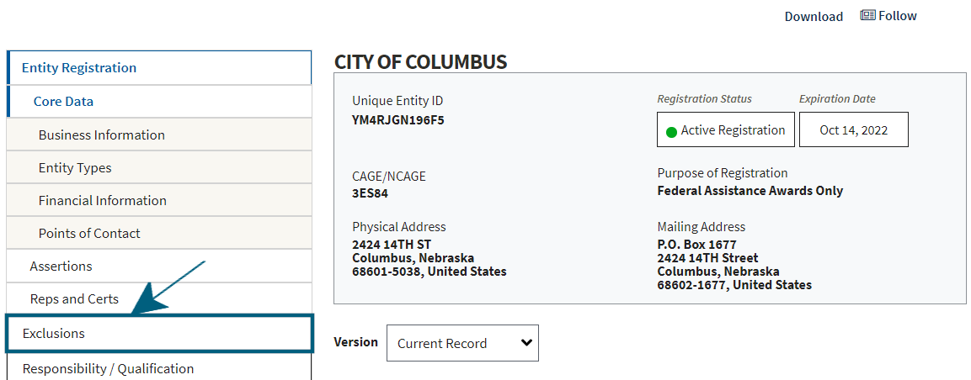

Then save the following screen for your entity and upload to AmpliFund (the user will need to capture the screen):

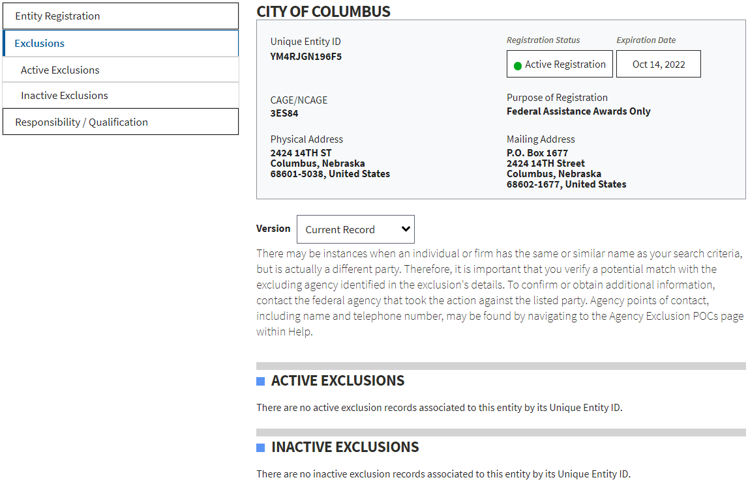

Instructions: Entity Owner

Go to sam.gov and click on “Sign In” on the right side of the screen

Accept the terms to sign into the site

Enter your login.gov sign-in credentials, if you do not have sign-in credentials, please create an account

Once you sign into the account, click on “Workspace” at the top right of the screen.
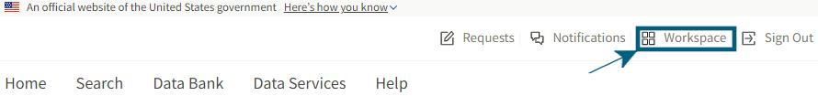

Click on the Active Entity registrations.
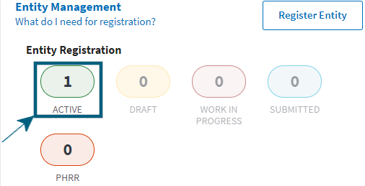

Once your organization populations, click on the three vertical dots on the right side of the screen.
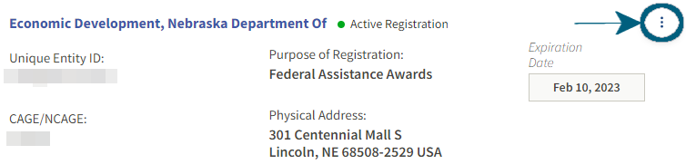

Click on “View Record”
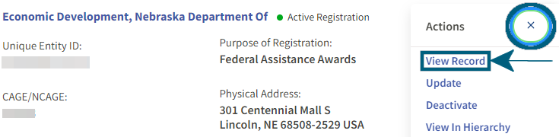

Click on “Download”
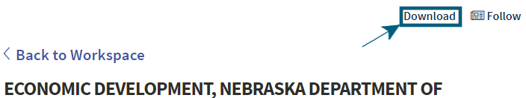

Enter the name of your entity in the name file and the date you downloaded the file. For example, if your entity was DED, type DED-20220609, then click on the PDF file type, then click on the download button. Depending on your browser, it should ask you to save the PDF file.

