**Exhibit O: Four Factor Analysis Template to Assess Limited English Proficiency**

**Record of Changes**

|  |  |
| --- | --- |
| **Date** | **Description of Change** |
| 2022 | Exhibit template added to CDBG website |
| 2023 | Updates to General Instructions. Added AmpliFund Directions. |
| 2024 | Added Recommended Provision of Written Language Assistance table. Added Footnotes 1 & 2. |
| 2025 | Significant edits were made to the calculation instructions within this guide. Instructions and links were updated. There were no substantive changes to the Four Factor Analysis. |

**INSTRUCTIONS:** The Four Factor Analysis to Assess Limited English Proficiency is required for all CDBG applications.

1. The top instructions outline how to pull language-related data for a community.
2. Farther below a template is provided, which should be updated to reflect the applicant’s information.

If you are not familiar with Limited English Proficiency Access Requirements, review definitions and further guidance, including how to write a Language Assistance Plan (LAP), in DED [CDBG Memo 14-01](https://opportunity.nebraska.gov/wp-content/uploads/2022/01/NEDED_HCD_Memo_14_01.pdf). In part, it reads,

*In order to gather information on the number and proportion of LEP persons served or encountered in the eligible service area, Subrecipients should use data from the U.S. Census Bureau American Community Survey (“ACS”). The ACS provides data that indicates the percentage and/or number of residents that speak English less than “very well.” The Subrecipient can use the ACS data on a county basis, or more in depth (political subdivision level), or if other data is available from a credible source that is representative of a more defined service area, the Sub-recipient may use that data.*

Access online training videos and support for how to use the data.census.gov website: <https://www.census.gov/data/what-is-data-census-gov.html>

To gather the required language spoken data:

1. Access
2. [https://data.census.gov/.](https://data.census.gov/.  )
3. [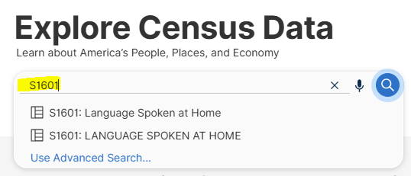](https://data.census.gov/.  )In the search bar, type: **S1601** Click either result in the list below (both reports generate the same results).
4. The next screen should comprise three “panes”.
   1. The left **Filters** pane may be hidden (click the **Filters** button at far left to reveal the pane if you do not see it by default.)

In a later step it is in this pane where you will set criteria to narrow your search from inclusion of all results for the United States, down to the community for which you are applying for a block grant. You may search here by community (Place), Census tract, Block group, and more.

* 1. The center pane contains choices for how the data will be displayed and has several tabs across the top.
     1. Click the **Tables** tab.
     2. Verify the correct report is showing: **S1601 | Language Spoken at Home**
  2. The right pane displays the results for which you filtered and chose to display per settings in the first two panes.

1. Graphical user interface, application

   AI-generated content may be incorrect.Click the **drop-down arrow** that is just to the left of the Notes button.
2. Graphical user interface, text, application, email

   AI-generated content may be incorrect.Select the **Most Recent ACS 5-Year Estimate Subject Table**.
3. Filter the data for the community*:
   1. In the left Filters pane, under the **Geographies** section heading, click **Place.**

*NOTE: If your project does not involve an entire community, you will instead filter data to match your project area. You may select Tract(s), Block Group(s), etc. for selected geographies. Your steps will be similar (but not identical) to those illustrated below.

* 1. In the center pane, in Search State (search bar), type Nebraska’s state abbreviation: **NE**.
  2. Click **Nebraska**.
  3. Check the box in front of the community for which you are pulling data. The results list in the right pane will refresh automatically.
  4. Click the “**X**” to collapse the center box so you can view the data in the right pane.

1. Export the data. First, you will analyze the data export to determine the number of LEP individuals and the percentage in the community. Later, you will eventually provide this export as part of the application process in the Exhibit O AmpliFund upload.
   1. Graphical user interface, table

      AI-generated content may be incorrect.Click the **More Tools** button (upper right corner) > **Print** > **Export to Excel.**
2. 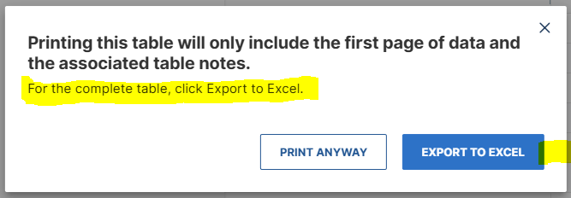Click **Export to Excel**.
3. Save the file. Example suggested file naming convention: *Norfolk* LEP Census Data Yr 2023 5-Year ACS as of 05-01-2025
4. A screenshot of a computer

   AI-generated content may be incorrect.The download may appear at the top of your browser window. Open the XLS spreadsheet. Note two tabs at the bottom: **Information** and **Data**.
5. 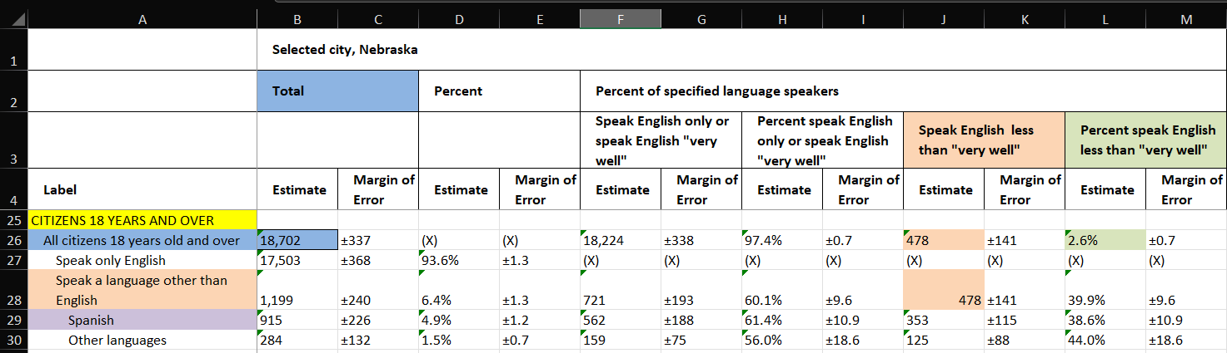It is recommended you click **Enable Editing**. Use the table to determine data related to LEP persons. **Scroll down to the section displaying information for citizens 18 years and over.**   
   In AmpliFund you will respond to the following **bolded** questions:
   1. **Total Population (##)** = Total Estimate All citizens 18 years old and over
      * In this example, cell B26: 18,702
   2. **Number of LEP Individuals in the Eligible Service Population (##)** = Total Estimate: Speak English less than “very well”
      * In this example, cells J26 & J28: 478
   3. **Percentage of LEP Individuals (#)** = Percent speak English less than “very well”
      * In this example, cell L26: 2.6% (478/1199=0.026)
   4. **1st Non-English Language Spoken (most common)**
      * In this example, cell A29: Spanish
   5. **Does the 2nd or 3rd Non-English Languages Spoken meet threshold that triggers a Language Assistance Plan (LAP) to be required?** (Yes/No)
      * Table

        AI-generated content may be incorrect.Thresholds include:

**AmpliFund Directions:**

1. Complete Four Factor Analysis template (following pages) & UPLOAD
2. UPLOAD: Census Data (via exported PDF)
3. Number of LEP Individuals in the Eligible Service Population (##)
4. Total Population (##)
5. Percentage of LEP Individuals (#)
6. 1st Non-English Language Spoken (most common)
7. Does the 2nd or 3rd Non-English Languages Spoken meet threshold that triggers a Language Assistance Plan (LAP) to be required?
8. Date of Four Factor Analysis Completion (MM/DD/YYYY)
9. As a result of the Four Factor Analysis has it been determined that a Language Assistance Plan is needed? (Y or N)

**FOUR FACTOR ANALYSIS**

**ASSESSING**

**LIMITED ENGLISH PROFICIENCY**

**PREPARED BY**

[Name of the Local Government Unit]

**FOR**

**THE COMMUNITY DEVELOPMENT BLOCK GRANT PROGRAM**

1. **POLICY STATEMENT**

It is the policy of the [Name of the Local Government Unit] to take reasonable steps to provide meaningful access to its programs and activities for persons with Limited English Proficiency (LEP). The [Name of the Local Government Unit]’s policy is to ensure that staff will communicate effectively with LEP individuals, and LEP individuals will have access to important programs and information. [Name of the Local Government Unit] is committed to complying with federal requirements in providing free meaningful access to its programs and activities for LEP persons.

1. **HISTORY**

Title VI of the Civil Rights Act of 1964 is the federal law which protects individuals from discrimination on the basis of their race, color, or national origin in programs that receive federal financial assistance. In certain situations, failure to ensure that persons who have Limited English Proficiency can effectively participate in, or benefit from, federally assisted programs may violate Title VI’s prohibition against national origin discrimination.

Persons who, as a result of national origin, do not speak English as their primary language and who have limited ability to speak, read, write, or understand English may be entitled to language assistance under Title VI in order to receive a particular service, benefit, or encounter.

On August 11, 2000, Executive Order 13166, titled, “Improving Access to Services by Persons with Limited English Proficiency,” was issued. Executive Order 13166 requires federal agencies to assess and address the needs of otherwise eligible persons seeking access to federally conducted programs and activities who, due to LEP cannot fully and equally participate in or benefit from those programs and activities. Section 2 of the Executive Order 13166 directs each federal department or agency "to prepare a plan to improve access to…federally conducted programs and activities by eligible LEP persons…."

1. **DEFINITIONS**

Beneficiary**:** The ultimate consumer of HUD programs and receives benefits from a HUD Recipient or Sub-recipient.

Limited English Proficient Person (LEP): Individuals who do not speak English as their primary language and who have a limited ability to read, write, speak, or understand English because of national origin.

Language Assistance Plan (LAP): A written implementation plan that addresses identified needs of the LEP persons served.

Recipient: Any political subdivision of the State of Nebraska, or an eligible nonprofit organization, to whom Federal financial assistance is extended for any program or activity, or who otherwise participates in carrying out such program or activity, including any successor, assign or transferee thereof, but such term does not include any Beneficiary under any such program.

Sub-recipient: Any public or private agency, institution, organization, or other entity to whom Federal financial assistance is extended, through another Recipient, for any program or activity, or who otherwise participates in carrying out such program or activity, but such term does not include any Beneficiary under any such program.

Vital Document: Any document that is critical for ensuring meaningful access to the Recipient’s major activities and programs by Beneficiaries generally and LEP persons specifically.

1. **FRAMEWORK & METHODOLOGY**

This Four Factor Analysis is the first step in providing meaningful access to federally funded programs for LEP persons. The Four Factor Analysis completed by [Name of the Local Government Unit] addresses the following:

1. The number or proportion of LEP persons eligible to be serviced or likely to be encountered by [Name of the Local Government Unit];
2. The frequency with which LEP persons using a particular language come in contact with [Name of the Local Government Unit];
3. The nature and importance of the [Name of the Local Government Unit]’s program or activity provided to the individual’s life; and
4. The resources available to [Name of the Local Government Unit], and costs associated with providing LEP services.

The program or activity covered within this analysis generally involves [CLICK TO INSERT USE SUMMARY].

1. **FOUR FACTOR ANALYSIS BY** [NAME OF THE LOCAL GOVERNMENT UNIT] for the described program or activity:
2. **The number or proportion of LEP persons eligible to be served or likely to be encountered.**
   * Describe prior experiences with LEP encounters and determine the breadth and scope of language services that were needed.
   * Cite actual numbers or percentages of LEP persons.
   * Identify the source of data used to identify LEP persons.

[CLICK TO INSERT ANALYSIS]

1. **The frequency with which LEP persons using a particular language come in contact.**
   * Describe the frequency with which LEP individuals may access your program, activity, or service as related to this specific CDBG-funded project.
   * Identify the top three languages, other than English, spoken in the eligible service population.
   * Include that the city will track inquiries for future documentation.

[CLICK TO INSERT ANALYSIS]

1. **The nature and importance of the above described** **program or activity provided to the individual’s life.**
   * Provide the name of activity/project and describe the specific activity, information, service, or program (Public Works, Downtown Revitalization, etc.),
   * State the importance of the project to an LEP person’s life.
   * Determine and describe whether denial or delay of access to services or information could have serious or even life-threatening implications for the LEP individual.

[CLICK TO INSERT ANALYSIS]

1. **The resources available to** [NAME OF THE LOCAL GOVERNMENT UNIT]**, and costs associated providing LEP services.**
   * Describe current resources that your agency can provide to assist an LEP individual if there is a communication need and discuss cost of resources.
   * If there is a lack of resources and/or cost burden then provide explanation, possible solutions, such as collaborating with local school, hospital, LEP grassroots organization, using telephone voicemail menu, hotline translation service, providing notice on non-English radio and TV stations, utilizing Google Translate, and/or ‘I Speak’ cards.
   * Local LEP contact staff and title is identified
   * Is there an LEP encounter tracking sheet created?
   * Are there any written or unwritten processes/procedures that an employee can utilize when encountering an LEP individual?

[CLICK TO INSERT ANALYSIS]

The Four Factor Analysis provides a baseline to determine what reasonable steps must be taken to ensure meaningful access for LEP persons. The Local Government Unit must ensure meaningful access for each LEP language group that constitutes 5% or 1,000 persons, whichever is less, of the population of persons eligible to be served or likely to be affected or encountered. Based on HUD guidance, the determination should be maintained by the Local Government Unit and updated at least *annually*. Based on the results of the Four Factor Analysis, the Local Government Unit may determine what specific language access services will best meet the needs of the LEP population.

As a result of the Four Factor Analysis completed on [Date] , [NAME OF THE LOCAL GOVERNMENT UNIT] has determined[1]:

|  |  |  |
| --- | --- | --- |
|  | **Size of Language Group** | **Recommended Provision of Written**  **Language Assistance** |
|  | 1,000 or more in the eligible population in the market area or among current beneficiaries | Translated Vital Documents[2] (LAP needed) |
|  | More than 5% of the eligible population or beneficiaries *and* more than 50 in number | Translated Vital Documents (LAP needed) |
|  | More than 5% of the eligible population or beneficiaries *and* 50 or less in number | Translated written notice of right to receive free oral interpretation of documents |
|  | 5% or less of the eligible population or beneficiaries and less than 1,000 in number | No written translation is required |

1. Federal Register January 22, 2007 ([FINALLEP2007.PDF (hud.gov)](https://www.govinfo.gov/content/pkg/FR-2007-01-22/pdf/07-217.pdf))
2. A vital document is any document that is critical for ensuring meaningful access to the recipients' major activities and programs by beneficiaries generally and LEP persons specifically.