

**EMERGENT THREAT-Public Facilities and Services** 2020 Pre-Application

COMMUNITY DEVELOPMENT BLOCK GRANT-CV

The Nebraska Department of Economic Development is accepting applications for Public Facilities or Public Services Projects under Emergent Threat by *invitation only*. Awards will be made through CARES ACT funding allocated to the Community Development Block Grant – Coronavirus Response (CDBG-CV) funding opportunity. Pre-applications are required for ALL eligible entities, in order to receive an invitation to apply to submit a full application. The pre-application process serves as determining eligibility, project’s fundability, national objective compliance and successful completion within the current timeline allowed. Applications for substantial construction or rehabilitation will not be considered.

### Eligible Applicants

Eligible Applicants include every Nebraska incorporated municipality (cities or counties) who are not classified as a CDBG Entitlement Community (entitlements communities are: Omaha, Lincoln, Bellevue, and Grand Island). CDBG-CV funds may be allocated to projects managed by for-profit or nonprofit entities through a Unit of Local Government. Every awarded project requires administration by a Certified Administrator under regular CDBG program rules. Eligible applicants with more than one eligible activity are required to submit a pre-application for each activity, thus needing more than one invitation to apply.

### Eligible Activities

The following activities are eligible within the CDBG-CV funding Opportunity. If any activity is not noted within the list below, please consult the CDBG Staff in order to determine if any other proposed activities are eligible for the program.

* ***Public Facilities/infrastructure:*** DED made funding available to local unit of governments to provide funding directed towards, recovering from, and responding to the COVID-19 Pandemic. This funding can be used to renovate and rehabilitate existing community facilities to serve their communities more effectively:
  + Senior Centers (03A)
  + Facilities for Persons with Disabilities (03B)
  + Facilities for Abused and Neglected Children (03Q)
  + Facilities for AIDS Patients (not operating costs) (03S)
  + Homeless Facilities (03C)
  + Youth Centers (03D)
  + Neighborhood Facilities (03E)
  + Child Care Centers (03M)
  + Health Facilities (03P)
  + Other Public Improvements (03Z)
* ***Public Services:*** DED made funding available to local unit of governments to provide funding directed towards building towards, recovering from, prevention of and responding to the COVID-19 Pandemic. This funding can be used to support needed community services, such as:
  + Senior Services
  + Services for Persons with Disabilities
  + Youth Services
  + Transportation Services
  + Child Care Services
  + Services for victims of domestic violence, dating violence, sexual assault or stalking
  + Health Services
  + Mental Health Services
  + Food Banks
  + Other Public Service

These funds can be used to add or expand services and pay for staffing and other operational costs associated with said activities

### National Objective Compliance

Meeting the National Objective is required before the Department can fund any activity with CDBG funds. A determination must be made as to whether the activity is eligible under Title I of the Housing and Community Development Act of 1974, as amended. Activities must also address at least one of the following three National Objectives of the CDBG Program: Benefit low and moderate income (LMI) persons, Aid in the prevention or elimination of slums or blight, and Meet other community development needs having a particular urgency, because existing conditions pose a serious and immediate threat to the health or welfare of the community and are of recent origin or recently became urgent, and where other financial resources are not reasonably available to meet such needs.

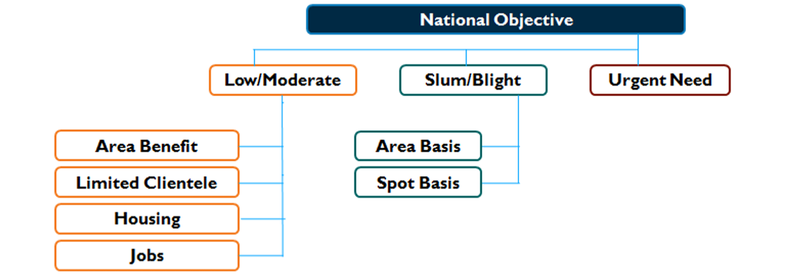

### Pre-Application Submission:

* The Pre-Application consists of:
  + Part I: General Information, including project tie-back to COVID-19 and if the project is new or an addition to already existing service.
  + Part II: Project Description (include details such as preliminary budget, ability to execute within 6-month timeframe, and specific needs for project)
  + Exhibits: National Objective Compliance (**contact program rep. for detailed instruction**)
    - Low and Moderate Income
      * Exhibit E: ACS Documentation (information can be found at https://www.hudexchange.info/programs/cdbg/cdbg-low-moderate-income-data/)
      * Exhibit E1: Census Income Survey (if applicable - project service area)
      * Exhibit E2: Random Sample Survey (if applicable - project service area)
      * Exhibit E3: Limited Clientele (useful for projects, involving food banks, senior centers, services for those with disabilities, etc.)
      * Exhibit E4: Jobs
    - Elimination of Slum and Blight
      * Exhibit F1: Slum and Blight on an Area Basis
      * Exhibit F2: Slum and Blight on a Spot Basis
* Submit electronically via email to designated program representative(s) in charge of Economic Development or Emergent Threat projects.
  + Tom Stephens ([tom.stephens@nebraska.gov](mailto:tom.stephens@nebraska.gov)) - Economic Development
  + Andrew Moffitt ([andrew.moffitt@nebraska.gov](mailto:andrew.moffitt@nebraska.gov)) -Public Services and Infrastructure
  + Laura Hart ([laura.hart@nebraska.gov](mailto:laura.hart@nebraska.gov)) – Public Services and Public Facilities

* Retain the **original Pre-Application signed by the Chief Elected Official** within your files.

# Pre-Application Form Instructions

## Part I. General Information Instructions

*Type all information except where signatures are required.*

**Box 1:** Provide the requested information.

**Box 2:** Provide the requested information. Check the appropriate application preparer status box.

**Box 3:** Check the appropriate box for the type of activity for which the application is made, including proposed activities to be funded with both CDBG funds and non-CDBG funds.

**Box 4:** Indicate the amount of CDBG Funds requested and other funds involved with this project.

**Box 5:** Check the appropriate box to indicate the applicant type under which funds are being requested.

**Box 6:** Brief description of the project for which CDBG funds are requested.

**Box 7:** Type the name and title of the Certifying Official and date. **Sign in blue ink.** The Certifying Official for a unit of general local government is the chief elected official.

## Part II. Project Description

Provide a one-page project description that describes the need for the project and the expected results when the project is completed. Include a timeline of benchmarks detailing **completion by May 31, 2023.** Documentation may be required by program representative.

## Exhibits: National Objective Compliance

Attach the appropriate exhibit documentation, located <https://opportunity.nebraska.gov/cdbg-cv>, which correlates with the CDBG activity proposed within the pre-application.

## 2020 PRE-APPLICATION

DED USE ONLY

Pre-Application Number

DED USE ONLY

Date Stamp Below

# EMERGENT THREAT (EM)

Community Development Block Grant-Coronavirus (CDBG-CV)

## Nebraska Department of Economic Development (DED)

## 

## PART I: GENERAL INFORMATION (TYPE OR PRINT ALL INFORMATION)

|  |  |  |  |  |  |  |
| --- | --- | --- | --- | --- | --- | --- |
| **1. APPLICANT IDENTIFICATION** | | | | **2. PERSON PREPARING APPLICATION** | | |
| Applicant Name |  | |  | Name | |  |
| Mailing Address |  | |  | Organization | |  |
| City, State, ZIP |  | |  | Address | |  |
| County |  | |  | City, State, ZIP | |  |
| Local Contact |  | |  | Email Address | |  |
| Email Address |  | |  | Telephone | |  |
| Telephone |  | |  | Federal ID # | |  |
| Federal ID # |  | |  |  | | |
| UEI # |  | |  | **Application Preparer (Check One)** | | |
| SAM Expiration Date |  | |  | Local Staff | Non-Profit | |
|  |  | | | Consultant | Economic Development District | |
| **3. ACTIVITY TYPE** | | | | **4. FUNDING SOURCE** | | |
| Public Services | |  | | **CDBG Funds** |  | |
| Public Facility/Infrastructure | |  | | **Other Funds** |  | |
| Other: | | | | **Total Cost** |  | |
|  | |  | | **5. APPLICATION TYPE** | | |
|  | |  | | Individual | Joint | |
|  | |  | |
| **6. USE SUMMARY:** Brief description of the project for which CDBG funds are requested. | | | | | | |
|  | | | | | | |
| **7. CERTIFYING OFFICIAL**: Chief elected officer of local government requesting CDBG funds. | | | | | | |
| To the best of my knowledge and belief, data and information in this application is true and correct, including any commitment of local or other resources. The governing body of the applicant has duly authorized this application. This applicant will comply with all Federal and state requirements governing the use of CDBG funds. | | | | | | |
|  | | | | | | |
| |  |  |  |  | | --- | --- | --- | --- | | **Signature in blue ink:** |  |  | | | **Typed Name and Title:** |  | Date Signed: |  | |  |  | | | | | | | | | |