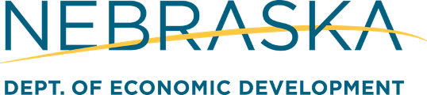

*We welcome you to use the following template to draft a press release announcing your grant from the Nebraska Department of Economic Development. When sending the press release to your media contacts, we recommend including the text of the release in the body of the email as well as including it as an attachment.*

**FOR IMMEDIATE RELEASE**

**CONTACT:**

Contact Name

Contact Title

Organization

Phone Number

Email Address

**[Your organization]receives [grant/loan] from the Nebraska Department of Economic Development [brief description of how the grant will be used. Ex: increase healthcare access for low-income families].**

[Organization] recently received a [$X, XXX grant/loan] from the Nebraska Department of Economic Development. The grant will help further [Organization’s] mission of ____________________________ by _______________________________________.

[Insert quote from Organization’s Executive Director or other staff person]

[If desired, insert more information about the program funded by the grant]

**About Organization**

[Place your organization’s boilerplate here: 2-5 sentence summary of the organization’s mission, including website and/or phone number.]

**About the Nebraska Department of Economic Development**

The Nebraska Department of Economic Development (DED) strategically invests state and federal program funds to support the growth of Nebraska’s communities and businesses. DED creates great opportunities for Nebraskans to enjoy the Good Life by helping to develop our people into highly skilled, tech-savvy workplace leaders. DED champions Nebraska’s brand nationwide and around the globe to attract investment, promote exports, and recruit diverse talent to the state. DED is dedicated to making it easy for entrepreneurs to excel, for small businesses to succeed, and for graduates to put down roots in Nebraska. As an agency, DED values relationships and partners closely with local governments, chambers of commerce, economic development organizations, utility providers, and educational institutions to grow Nebraska.For more information, go to https://opportunity.nebraska.gov or email kate.ellingson@nebraksa.gov.