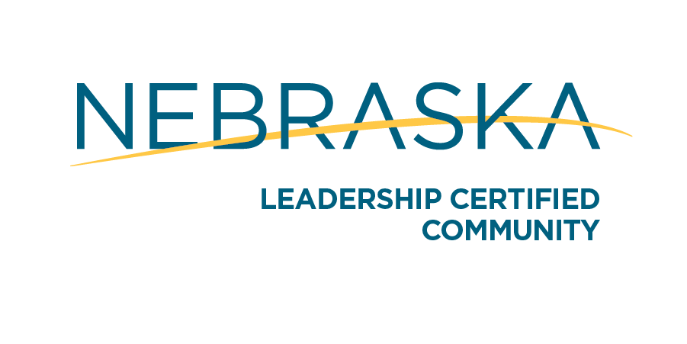
Leadership Certified Community Recertification Requirements
Leadership Designation is valid for five years. Community websites are subject to annual reviews, those found to be outdated and/or inconsistent with the necessary information will result in suspension of certification and associated benefits.

Communities desiring to maintain their Leadership Designation are required to apply for recertification prior to the end of their five year designation period. A reminder notification will be given prior to the recertification deadline. Communities seeking recertification should submit clear and concise narrative response to the following items. The original narrative as provided at the time the community was designated and associated supplemental materials are retained in Department files. Responses should reference the original application, providing updated responses based on the past five years and moving forward. If there are any questions please contact Kelly Gewecke at kelly.gewecke@nebraska.gov or call 308-627-3151
SECTION ONE-COMMUNITY
LOCAL GOVERNMENT SUPPORT
Provide evidence of support for recertification, including:
- A resolution from the applicant’s municipal government stating the community would like to recertify as a Nebraska Department of Economic Development Leadership Community and identify the lead local contact person for the recertification application.
- Letters of support from any regional or neighboring economic development entities (e.g. multi-county economic development agencies, utility partners or development districts).

COMMUNITY COLLABORATION EFFORTS
- Describe how the community continues to collaborate with local organizations.
- Discuss any new organizations and/or activities in the community and how the organizations work together for community betterment.

COMMUNITY VOLUNTEERISM
- Describe how the level of volunteerism continued to evolve over the past 5 years, including any new efforts.
- Discuss any new volunteer recruitment and/or appreciation efforts that have taken place.

COMMUNITY LEADERSHIP
A. Describe any formal or informal community efforts to recruit and/or train future leaders within the community both youth and adult.
B. Describe what the community is doing to communicate with graduates and alumni to retain and or move back to the community.

SECTION TWO-STRATEGIC PLANNING

COMMUNITY ASSESSMENT
- Reflect on the community assessment completed at the time of designation (and any and all subsequent assessments), providing a narrative regarding any changes to those issues identified.
- Describe any updated processes and tools used to conduct on-going community assessment efforts in the last 5 years, including:
  - A description of the involvement of key stakeholders and the community at large.
  - A summary of results from the assessment process identifying any new issues, providing an explanatory narrative where appropriate.
- Attach a copy of any reports developed as a result of the community assessment.

COMMUNITY PROFILE
- Provide the link for your online Location One Information System (LOIS) community profile.
- Update all LOIS information
- Describe any changes to the process for maintaining an up-to-date profile.

STRATEGIC PLAN
- Identify and summarize any completed projects as they relate to the strategic plan submitted at the time of designation, and any subsequent plans.
- Provide a summary of the most recent community strategic plan, including the process used for its development. The strategic plan must be current or reviewed within the past 12 months, and include an economic development strategic plan. Overall, the plan should include: identified issues, goals and objectives, and action steps developed to address the issues.
- Did the strategic plan address the issues listed during the most recent community assessment process? Discuss these issues and the goals and objectives identified to meet any challenges in these areas.
- Attach a copy of the most recent community strategic plan and/or provide a link to an online version.

SECTION THREE - COMMUNITY PLANNING & ZONING

COMPREHENSIVE PLAN
- Provide a summary of any updates, identifying any progress made within the community with respect to the community’s comprehensive plan. Indicate how often the comprehensive plan is formally and/or informally reviewed and updated, providing a description of that process.
- Identify any changes and/or updates to goals and objectives therein.
- Attach a copy of the comprehensive plan, or provide a link to an online version.

CAPITAL IMPROVEMENT PLAN

A. Describe any progress regarding the capital improvement plan as submitted at the time of designation, and any changes and/or additional elements.

B. Attach a copy of the current capital improvement plan and/or provide an online link.

ZONING & SUBDIVISION ORDINANCES

Describe any significant updates to the community’s zoning and subdivision ordinances, providing context where appropriate.

BUILDING CODES & PERMITS

A. Describe any updates and/or additions to the housing and building codes.

B. Describe any updates to the process for issuing building permits in the community.

C. How many building permits were issued within the last year? How many were new houses?

CODE ENFORCEMENT
A. Describe any updates to the current nuisance ordinances, the process for inspection, and code enforcement.
B. How many code violations have there been in the last year?
C. Attach a copy of any new building codes, housing codes, and nuisance ordinances; and /or provide a link to online versions. Include a summary of any and all changes made since the time of designation.

SECTION FOUR - BUSINESS & TECHNOLOGY

BUSINESS RETENTION & EXPANSION (BRE) PROGRAM
Provide an updated summary of how the BRE Strategy has been working within the community and any changes made to the process, including:
A. How many businesses are located in the community?
B. How many businesses are visited annually (see the guidelines below)?

C. Please list the businesses that were visited in the last 12 months.

D. How are visits conducted, and who is involved?

E. What is done with data collected?

F. How is follow-up initiated and tracked?

G. Provide an explanation of how local businesses are communicated with.

H. Provide an explanation of how local businesses are recognized.

Guideline for the number of Businesses to visit Annually
Population: | Number of Interviews
Less than 1,000 | 10
1,000 – 3,000 | 15
3,000-5,000 | 20
5,000- 7,000 | 25
7,000-10,000 | 30
Over 10,000 | 35

ONLINE PRESENCE

The community must have a working and updated website. Provide a link to the community’s website and identify who is responsible for keeping the website content updated. Note: all links must be working.

The review committee will ensure the applicable website includes:

- Identification
  - Name of community or organization.
  - Name of State – Nebraska clearly shown.
  - Map showing location of community within Nebraska.
  - Location identification found on every page.
  - Action photos showcasing the community.

- Contact Information
  - Complete information (i.e. physical address, telephone with area code, email address, etc.).
  - Contact information found clearly on home page and in the footer/header/sidebar of every page of the site.
  - Emails should be “hot” or working, and spelled out – not somebody’s name underlined, or a sentence saying “email us.”
  - If the page features a “Contact Us” button or tab – it should open up another page on the website with the same look and feel and should contain contact information. This should NEVER be a link that automatically opens as an email.

- Navigation
- Should be intuitive and easy to follow.
- Easy to identify where you are within the site at all times.
- Provides a way back to the home page without having to use the “back” button

- Community information should include but not be limited to:
  - Employment Opportunities
  - Housing
  - Utility Information
  - Existing Businesses Information
  - Tourist Opportunities (i.e. local attractions, recreation, lodging, restaurants, etc.)
  - Local Volunteer and Leadership Opportunities
  - Community Calendar (featuring local events and celebrations)
  - Community Profile Website must have Location One Information System integrated or linked to website, so the Community Profile is accessible to the viewer.

SECTION FIVE - IMPLEMENTATION

BUSINESS & ENTREPRENEURIAL ASSISTANCE

Submit an updated summary of local, regional and state business and entrepreneurial assistance programs available to your business community. The summary should include technical support, business mentoring/coaching services, financial support, etc. These resources should be available on the community’s website.

FINANCING & INCENTIVE RESOURCES

Provide an updated summary of local and regional financing and incentive programs available to your business community. The summary should include a brief description of local and regional revolving loan funds, LB840 program guidelines, Community Development Block Grant reuse funds, investment clubs, community bonding authority, bank etc. Do not include state financing and incentives in your response.

Name of Applicant Community

______________________________________________________________________________
Printed Name and Signature of Chief Elected Official of the Applicant Community

______________________________
Date

______________________________________________________________________________

Printed Name and Signature of Application Coordinator

______________________________
Date

Coordinator Contact Information:

